**Practical No. 4**

**Aim:- Perform data mining on super market data using K-means cluster algorithm.**

**Steps:-**

1. **Open a weka tool using console.**

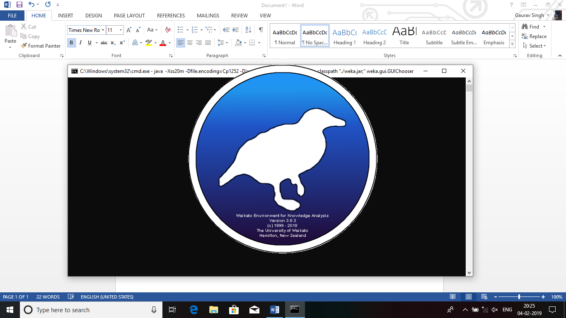

1. **Weka GUI Chooser is appear on window and Select the Explorer from applications menu.**

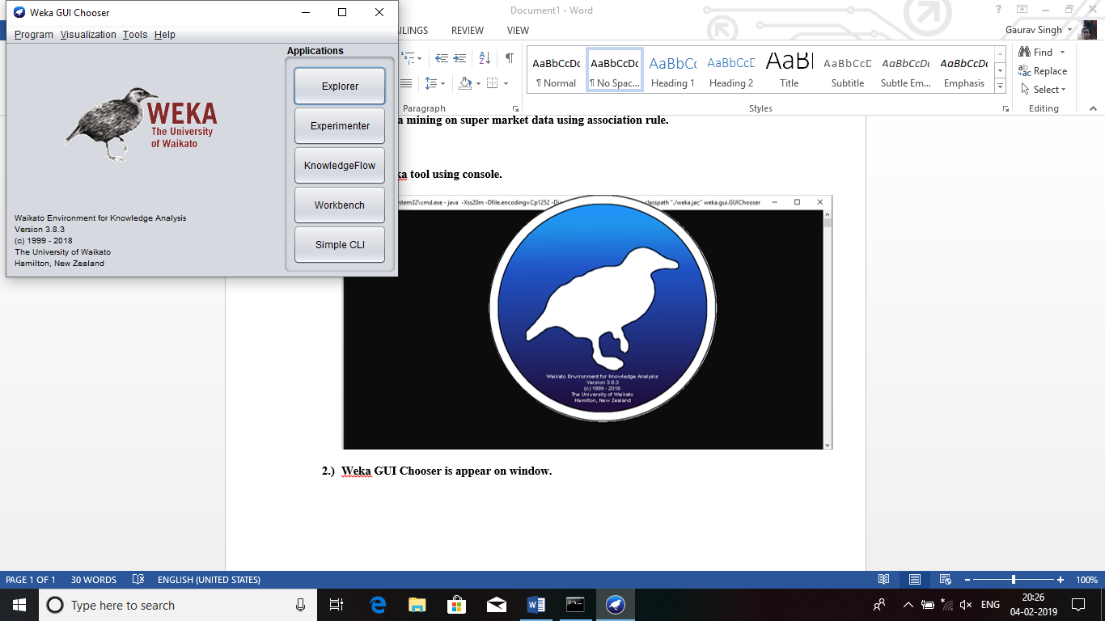

1. 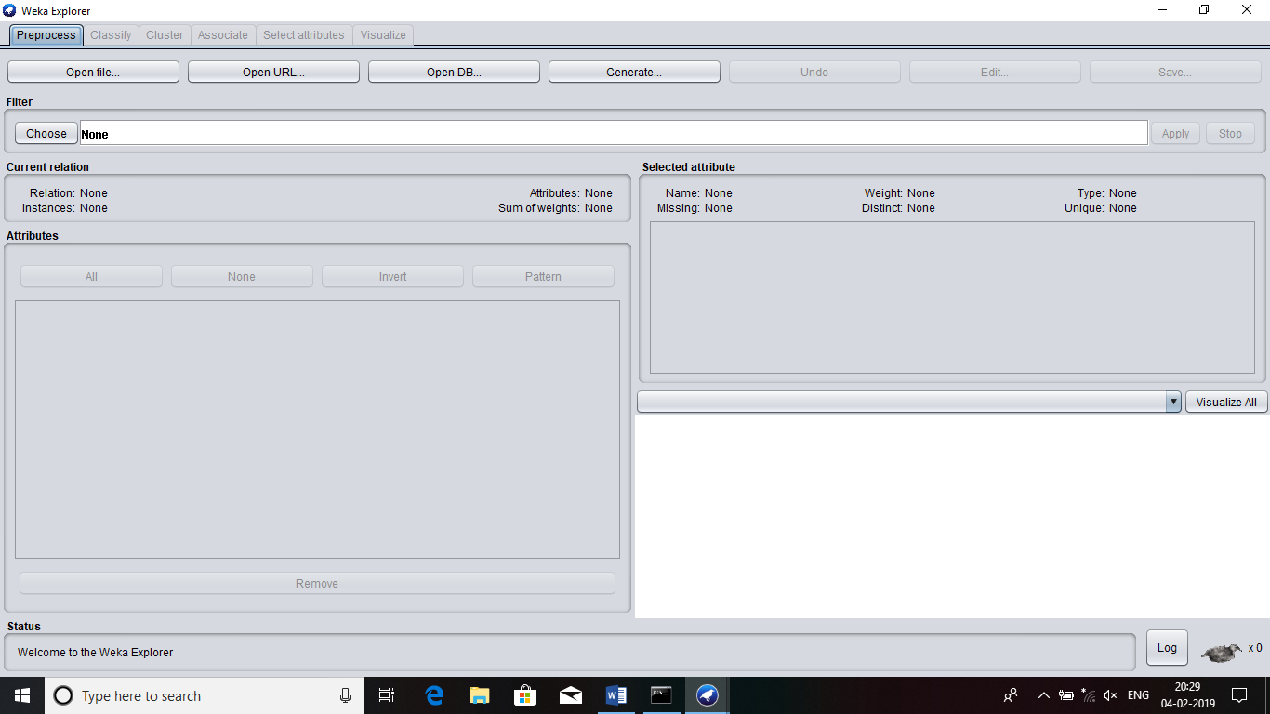**Explorer window is open.**
2. 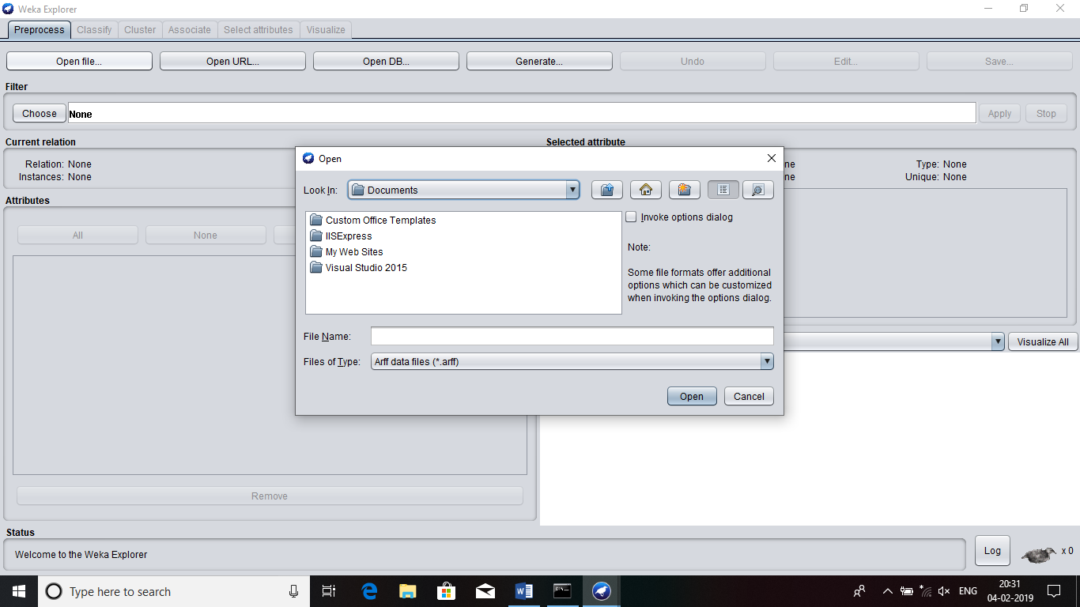**Click on Open file.**
3. 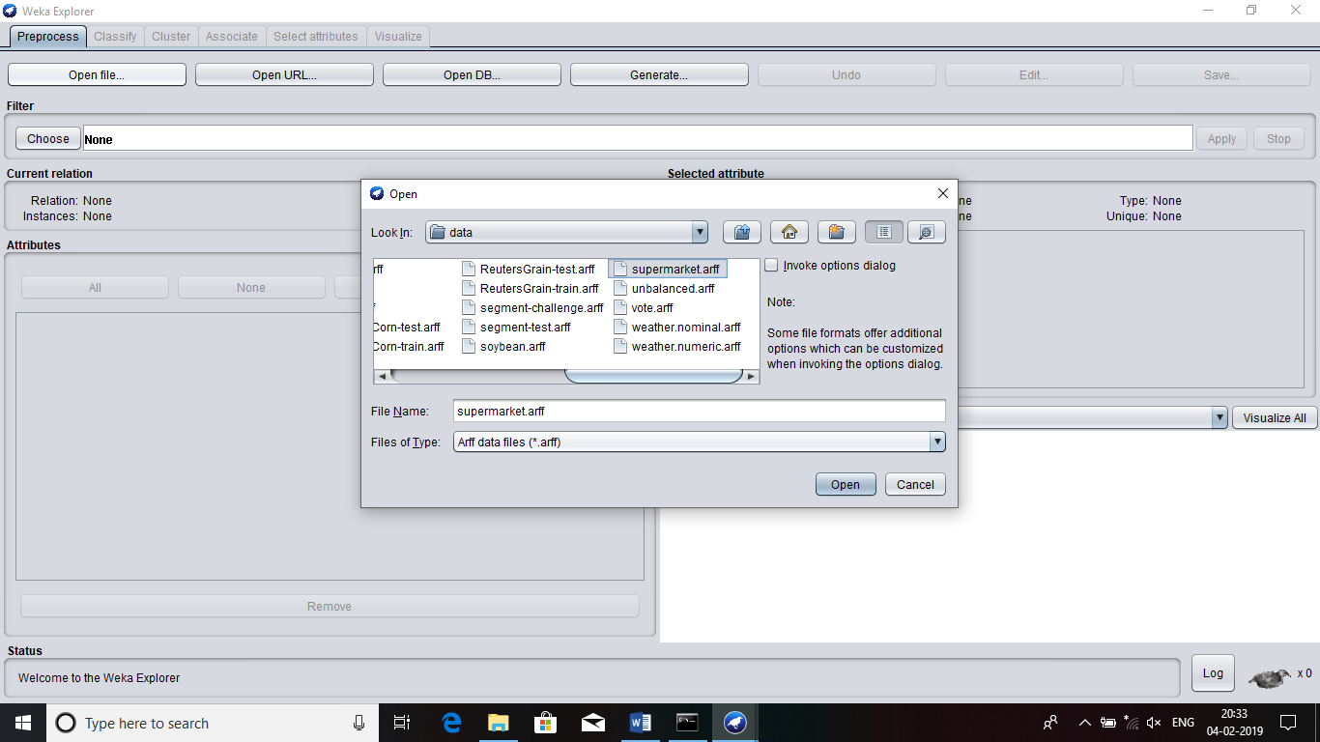**Select the supermarket.arff file from data folder.**
4. **Supermarket.arff file is open in Weka Explorer.**

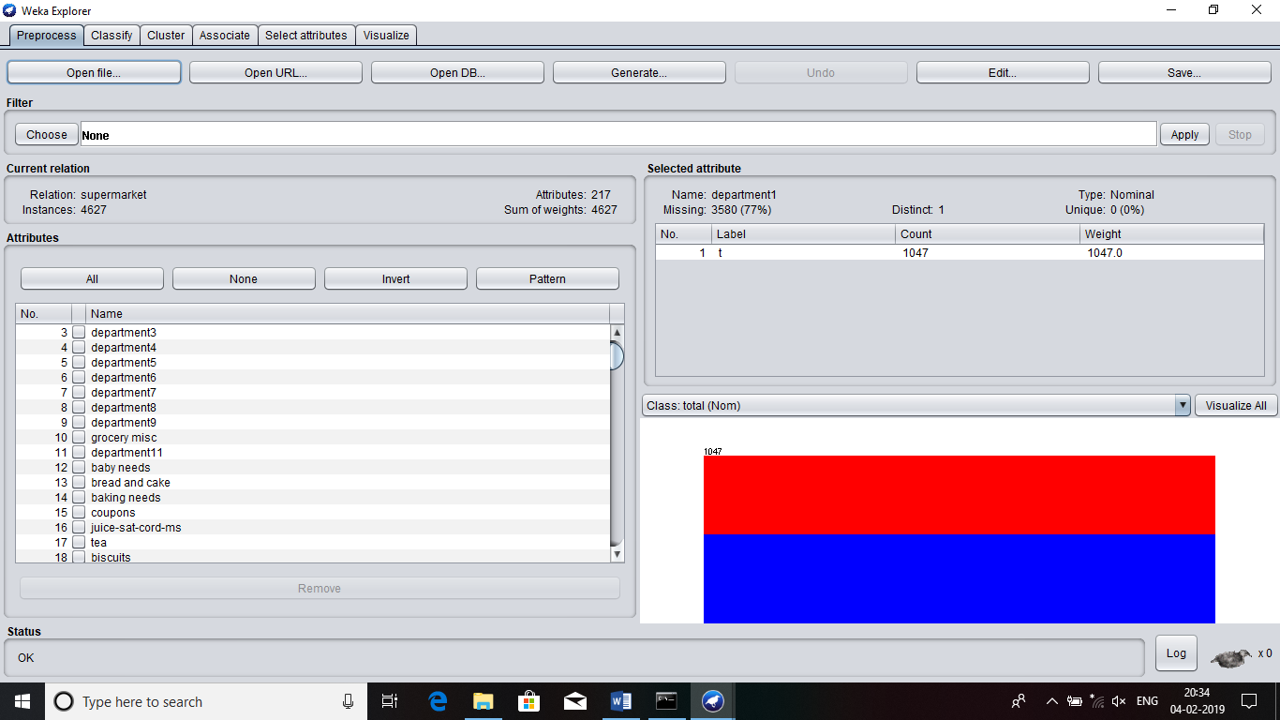

1. 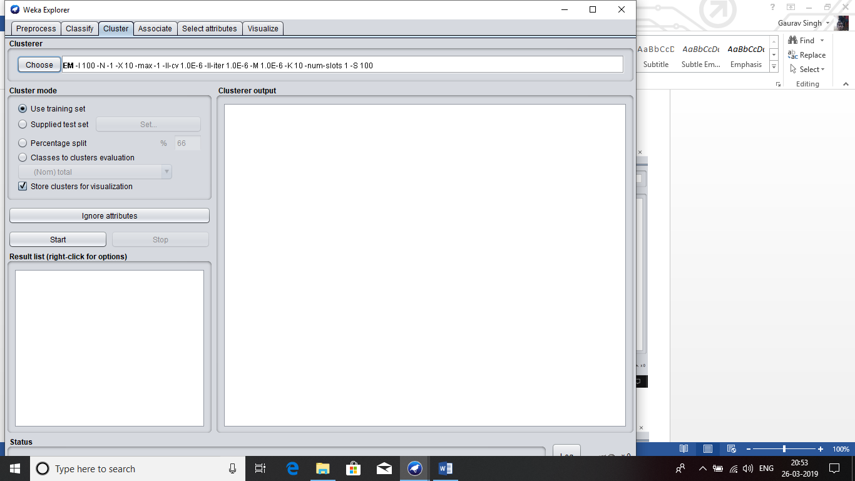**Click on Cluster tab.**
2. 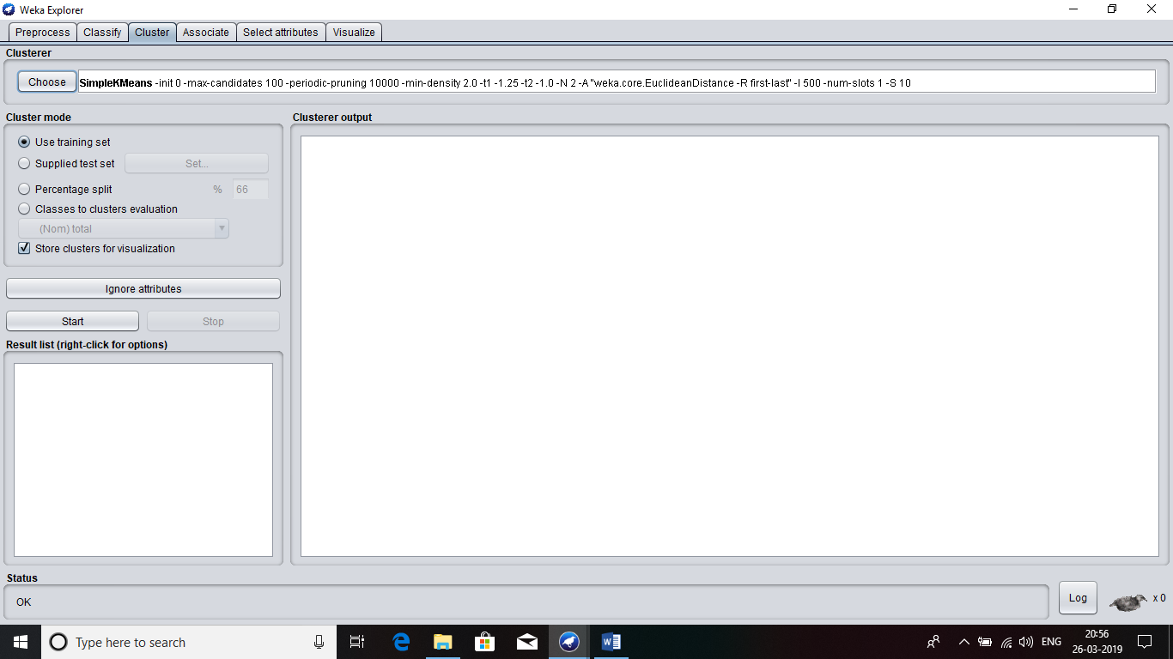**Select the SimpleKMeans option.**
3. 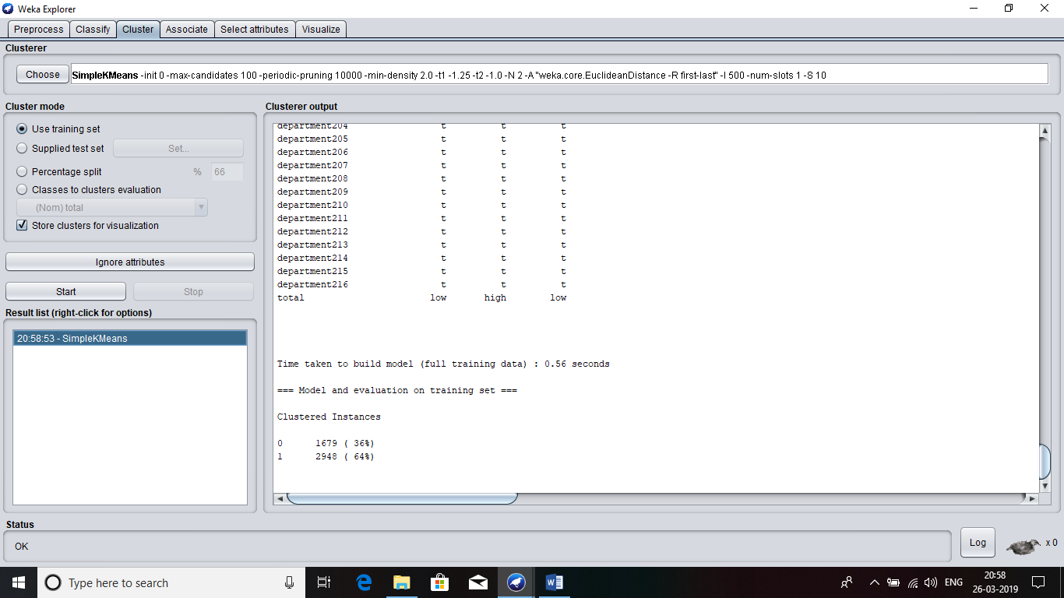**Result of K-means cluster algorithm.**